64CH NVR 12MP/8MP/6MP/5MP/4MP/3MP/1080P/960P/720P HD NVR

Model**LDSNVRR6864G**

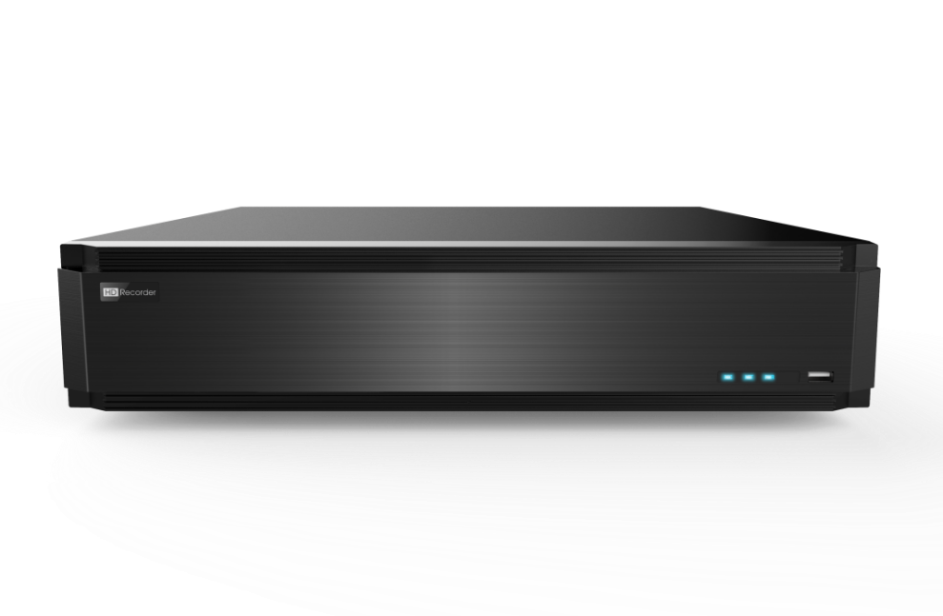

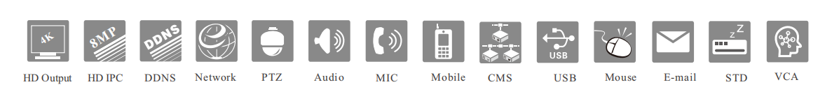

Features：

 Supports 64 CH 12MP / 8MP / 6MP / 5MP / 4MP / 3MP / 1080P / 1280×1024/ 960P / 720P / 960H / D1 / CIF IP input

 H.265S/H.265+/H.265/H.254 high profile compression

 Intuitive and user-friendly Graphic User Interface ( GUI ) , Windows style operation by mouse

 Multi-mode recording: manual / timed / motion / sensor/ POS / AI recording

 Playback : 16 CH simultaneous playback

 Search : time slice , time , event , tag search and smart search

 Supports multiple VCA (Video Content Analytics) events , such as object abandoned/missing , region intrusion , tripwire , video exception , etc .

 Supports POS information overlay on live view and playback

 Supports RAID0 , RAID1 , RAID5 , RAID6 , RAID10

 Express and flexible backup via USB , network and so on

 Pentaplex : preview, record, playback, backup and remote access

 DHCP, DDNS , PPPoE network protocol

 Remote control via Web Client or CMS : preview, playback, backup , PTZ and configuration

 Dual stream technology for local storage with high definition , remote network transmission and remote surveillance with mobile device

 Multi-user online simultaneously

 Authorization management, log view and device status view

 4K output , true high resolution display

 Supports PTZ preset and auto cruise , up to 255 presets and 8 cruises

 Supports NAT function and QRCode scanning by mobile phones

 Powerful mobile surveillance by smart phones with iOS and Andriod OS

Specifications:

|  |  |  |
| --- | --- | --- |
| Model | | **LDSNVRR6864G** |
| System | OS | Embedded Linux |
| Video | Network Input | 64 CH IPC input |
| Incoming  Bandwidth | 320Mbps |
| Outgoing  Bandwidth | 320Mbps |
| Network Input Resolution | 12MP/ 8MP/ 6MP/5MP/4MP/3MP/ 1080P/ 1280 × 1024/960P/ 720P/960H/D1/CIF |
| Output | HDMI 1 : 3840 × 2160@60fps / 3840 × 2160@30fps /  1920 × 1080 /1280×1024 / 1024 × 768  HDMI 2: 1920 × 1080/ 1280×1024 / 1024 × 768  VGA × 1: 1920 × 1080 / 1280×1024 / 1024 × 768 |
| Compression | H.265S/H.265+/H.265/H.264 |
| Multi-screen display | 1/4/6/8/9/ 13/ 16/25/32/36/64 |
| Audio | Network Input | 64 CH IPC audio input |
| 2-way Audio | RCA × 1 |
| Local Output | RCA × 1 |
| Compression | G.711(U/A) |
| Record | Record Stream | Dual stream recording |
| Resolution | 12MP@20fps; 8MP/ 6MP/5MP/4MP/3MP/ 1080P/ 1280 × 1024/ 960P/ 720P/960H/D1/CIF@30fps(NTSC)/25fps(PAL) |
| Mode | Manual/timed/motion/sensor/POS/AI recording |
| Playback | Simultaneous Playback | Max 16 CH |
| Search | Time slice / time / event / tag / smart search |
| Smart Search | Highlighted color to display the camera record in a certain  period of time, different colors refers to different record events |
| Function | Play, pause , FF, FB, digital zoom , etc . |
| Decoding Capability | Live View/  Playback | 1CH 12MP / 4 CH 5MP / 9 CH 720P/ 16CH 720P |
| Alarm | Mode | Manual , sensor, motion , exception , smart events |
| Input | 8 CH local alarm input; supports IPC alarm input |
| Output | 4 CH |
| Triggering | Record , snapshot, buzzer, preset , e-mail , etc . |
| Video  Structure  Analysis | Human/Vehicle Classification | Yes |
| Other Functions | Fisheye | Supports fisheye dewarping via Web Client and mobile APP |
| Plate Recognition | Yes |
| Network | Interface | RJ 45 10 / 100 / 1000 Mbps × 2 |
| Protocol | TCP / IP, PPPoE , DHCP, DNS , DDNS , UPnP, NTP, SMTP, HTTP, HTTPs , 802 . 1x , ONVIF, etc . |
| Client Connection | Max .20 users access |
| Mobile  Device | OS | iOS , Andriod |
| Storage | HDD Interface | SATA×8 , up to 8TB per HDD; E-SATA×2 |
| RAID | RAID0 , RAID1 , RAID5 , RAID6 , RAID10 |
| Backup | Local Backup | U disk, USB mobile HDD |
| Network Backup | Yes |
| Port | USB | USB2 .0 × 2 , USB3 .0 × 1 |
| RS 485 | Yes (full-duplex) ; connectors for PTZ and keyboard |
| Remote  Controller | Yes |
| Others | Power Supply | ATX 250W |
| Consumption | ≤ 30W ( without HDD ) |
| Dimensions  (mm) | 445 × 436 × 90 (W × D × H) |
| Working Environment | - 10 ～ 50 ℃ , 10% ～ 90% humidity |
| Certificate | CE, FCC |
| Environmental Protection | Complies with Directive EU RoHS , REACH and WEEE |

**Rear Panels:**

NVR6864G

